**Project Design Phase-II**

**Data Flow Diagram & User Stories**

|  |  |
| --- | --- |
| Date | 03 October 2022 |
| Team ID | PNT2022TMID26770 |
| Project Name | Project – Natural Disasters Intensity Analysis and Classification using Artificial Intelligence |
| Maximum Marks | 4 Marks |

**Data Flow Diagrams:**

A Data Flow Diagram (DFD) is a traditional visual representation of the information flows within a system. A neat and clear DFD can depict the right amount of the system requirement graphically. It shows how data enters and leaves the system, what changes the information, and where data is stored.

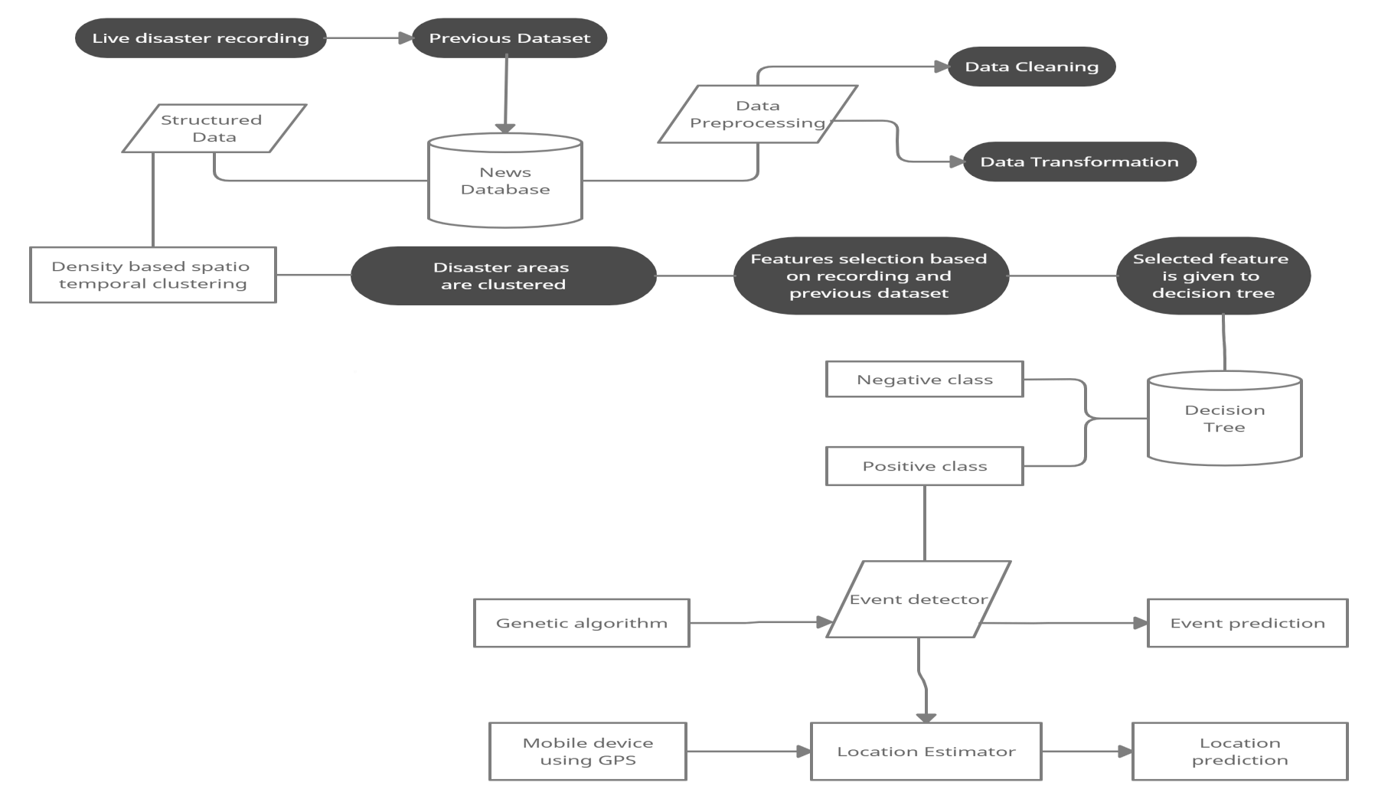

**User Stories**

Use the below template to list all the user stories for the product.

|  |  |  |  |  |  |  |
| --- | --- | --- | --- | --- | --- | --- |
| **User Type** | **Functional**  **Requirement**  **(Epic)** | **User Story**  **Number** | **User Story / Task** | **Acceptance criteria** | **Priority** | **Release** |
| Customer  (Mobile user) | Registration | USN-1 | As a user, I can register for the application by entering my email, password, and confirming my password. | I can access my account / dashboard | High | Sprint-1 |
|  | Login /Dashboard | USN-2 | As a user, I will receive confirmation email once I have registered for the application | I can receive confirmation email & click confirm | High | Sprint-1 |
| Customer (Web user) | Registration | USN-3 | As a user, I can register for the application through Gmail | I can register & access the dashboard wih google | Low | Sprint-1 |
|  | Login /Dashboard | USN-4 | As a user, I can log into the application by entering email & password | I can access my account / dashboard | Medium | Sprint-1 |
| Admin | Login | USN-5 | Admin can change the data and monitor the functionality of the programme. | Admin can carry out actions and make modifications. | High | Sprint-1 |
| Seismologist | Disaster prediction | USN-6 | Seismologists use the website to review the previous dataset and contrast it with the current data. | They can draw the conclusion about the seismic influence based on the results. | High | Sprint-2 |
|  |  | USN-7 |  | They can forewarn of impending events in advance. | High | Sprint-2 |
| Meteorologists | Disaster prediction | USN-8 | Meteorologists use this website to monitor global weather and climate fluctuations. | They are able to give early warning of imminent events. | Medium | Sprint-2 |
| NDRF | Rescue | USN-9 | In order to save more lives, they can expedite the rescue effort thanks to the early warning. | Their fast response can reduce casualties. | High | Sprint-2 |